**Chapter 5 – Team Project: Creating and Manipulating a Relational Database for Team Project**

Read the sample project steps for this chapter and apply the same techniques to the team project that you are developing. For the relational schema you developed at the end of Chapter 4 for the team project, carry out the following steps to implement the design using Oracle:

**Step 5.1 – Review and update the data dictionary and list of assumptions (as needed).**

For each table, write the table name and write out the names, data types, and sizes of all the data items, and identify any constraints, using the conventions of the DBMS you will use for implementation.

No changes were made to the list of assumptions.

**TABLE Member**

memberId VARCHAR 10 PRIMARY KEY

dateJoined DATE

lastName VARCHAR2 20 NOT NULL

firstName VARCHAR2 15 NOT NULL

street VARCHAR2 50

city VARCHAR2 15

state CHAR 2

zip CHAR 5

areaCode CHAR 3

phoneNumber CHAR 7

currentOfficeHeld VARCHAR2 50

**TABLE DuesPayment**

duesYear NUMBER 4 (duesYear,memberId )PRIMARY KEY

memberId VARCHAR 10 (duesYear,memberId) PRIMARY KEY

amount NUMBER 3 NOT NULL

datePaid DATE NOT NULL

**Table Play**

title VARCHAR2 20 PRIMARY KEY

author VARCHAR2 20

numberOfActs NUMBER 2

setChanges NUMBER 2

**TABLE Production**

year NUMBER 4 (year, seasonStartDate) PRIMARY KEY

seasonStartDate DATE (year, seasonStartDate) PRIMARY KEY

seasonEndDate DATE

title VARCHAR2 20 FOREIGN KEY

**TABLE MemberProduction**

memberID VARCHAR 10 (memberId, year, seasonStartDate)PRIMARY KEY

year NUMBER 4 (memberId, year, seasonStartDate)PRIMARY KEY

seasonStartDate DATE (memberId, year, seasonStartDate)PRIMARY KEY

role VARCHAR2 15

task VARCHAR2 15

**TABLE Performance**

perfDate DATE (perfDate, year) PRIMARY KEY

year NUMBER 4 (perfDate, year) PRIMARY KEY

time CHAR 5 /* "hh:mm" */

seasonStartDate DATE FOREIGN KEY

**TABLE Subscriber**

subID VARCHAR2 10 PRIMARY KEY

firstName VARCHAR2 15

lastName VARCHAR2 20

street VARCHAR2 50

city VARCHAR2 15

state CHAR 2

zip CHAR 5

areaCode CHAR 3

phoneNumber CHAR 7

**TABLE TicketSale**

saleID VARCHAR2 10 PRIMARY KEY

saleDate DATE

totalAmount NUMBER 7,2

perfDate DATE (perfDate, perfYear) FOREIGN KEY

perfYear NUMBER 4 (perfDate, perfYear) FOREIGN KEY

subID VARCHAR2 10 FOREIGN KEY

**TABLE Ticket**

saleID VARCHAR2 10 (saleID, seatLocation) PRIMARY KEY

seatLocation VARCHAR2 10 (saleID, seatLocation) PRIMARY KEY

price Number (8,2)

type VARCHAR2 10

**TABLE Sponsor**

sponsorID VARCHAR2 10 PRIMARY KEY

name VARCHAR2 20

street VARCHAR2 50

city VARCHAR2 15

state CHAR 2

zip CHAR 5

areaCode CHAR 3

phoneNumber CHAR 7

**TABLE Donation**

sponsorID VARCHAR2 10 (sponsorID, donationDate) PRIMARY KEY

donationDate DATE (sponsorID, donationDate) PRIMARY KEY

donationType VARCHAR2 20

donationValue NUMBER 7,2

year NUMBER 4 (year, seasonStartDate) FOREIGN KEY

seasonStartDate DATE (year, seasonStartDate) FOREIGN KEY

**Step 5.2 – Design SQL statements to create all tables needed to implement the design. Then create the tables in the database.** Show your work by providing screenshots of executing the CREATE TABLE SQL statements in the database.

CREATE TABLE MEMBER(

memberId VARCHAR(10) NOT NULL,

dateJoined DATE,

lastName VARCHAR2(20) NOT NULL,

firstName VARCHAR2(15) NOT NULL,

street VARCHAR2(50),

city VARCHAR2(15),

state CHAR(2),

zip CHAR(5),

areaCode CHAR(3),

phoneNumber CHAR(7),

currentOfficeHeld VARCHAR2(50),

CONSTRAINT MEMBER_pk PRIMARY KEY (memberId));

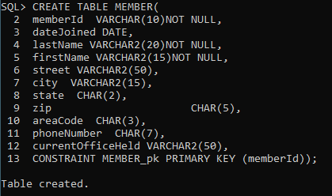

CREATE TABLE DUESPAYMENT(

duesYear NUMBER(4) NOT NULL,

memberId VARCHAR(10) NOT NULL,

amount NUMBER(3) NOT NULL,

datePaid DATE NOT NULL,

CONSTRAINT DUESPAYMENT_pk PRIMARY KEY (duesYear,memberId),

CONSTRAINT DUESPAYMENT_member_id_fk FOREIGN KEY(memberId) REFERENCES MEMBER (memberId) ON DELETE CASCADE);

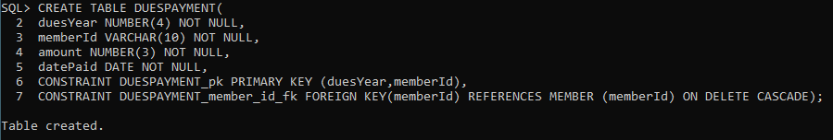

CREATE TABLE PLAY(

title VARCHAR2(20) NOT NULL,

author VARCHAR2(20),

numberOfActs NUMBER(2),

setChanges NUMBER(2),

CONSTRAINT PLAY_pk PRIMARY KEY (title));

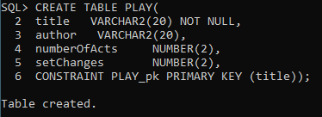

CREATE TABLE PRODUCTION(

year NUMBER(4),

seasonStartDate DATE,

seasonEndDate DATE NOT NULL,

title VARCHAR2(20),

CONSTRAINT PRODUCTION_pk PRIMARY KEY (year, seasonStartDate),

CONSTRAINT PRODUCTION_title_fk FOREIGN KEY(title) REFERENCES PLAY (title) ON DELETE CASCADE);

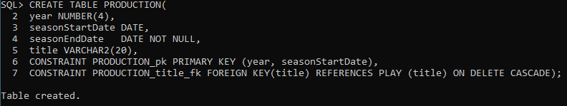

CREATE TABLE MemberProduction(

memberID VARCHAR(10) NOT NULL,

year NUMBER(4) NOT NULL,

seasonStartDate DATE NOT NULL,

role VARCHAR2(15) NOT NULL,

task VARCHAR2(15) NOT NULL,

CONSTRAINT MemberProduction_pk PRIMARY KEY (memberId, year, seasonStartDate),

CONSTRAINT MemberProduction_memberid_fk FOREIGN KEY (memberId) REFERENCES MEMBER (memberId) ON DELETE CASCADE,

CONSTRAINT MemberProduction_year_season_start_fk FOREIGN KEY(year, seasonStartDate) REFERENCES PRODUCTION (year, seasonStartDate) ON DELETE CASCADE);

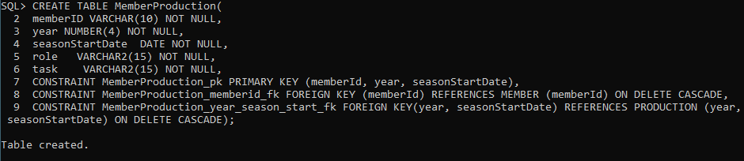

CREATE TABLE Performance(

perfDate DATE,

year NUMBER(4),

time CHAR(5),

seasonStartDate DATE,

CONSTRAINT Performance_pk PRIMARY KEY (perfDate, year),

CONSTRAINT Performance_year_season_start_fk FOREIGN KEY(year, seasonStartDate) REFERENCES PRODUCTION (year, seasonStartDate) ON DELETE CASCADE);

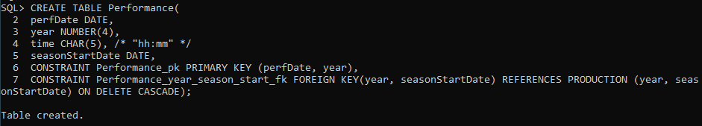

CREATE TABLE Subscriber(

subID VARCHAR2(10),

firstName VARCHAR2(15),

lastName VARCHAR2(20),

street VARCHAR2(50),

city VARCHAR2(15),

state CHAR(2),

zip CHAR(5),

areaCode CHAR(3),

phoneNumber CHAR(7),

CONSTRAINT Subscriber_pk PRIMARY KEY (subID));

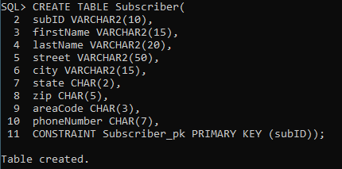

CREATE TABLE TicketSale(

saleID VARCHAR2(10),

saleDate DATE,

totalAmount NUMBER(7,2),

perfDate DATE,

perfYear NUMBER(4),

subID VARCHAR2(10),

CONSTRAINT TicketSale_pk PRIMARY KEY (saleID),

CONSTRAINT TicketSale_perfYear_fk FOREIGN KEY(perfDate, perfYear) REFERENCES Performance (perfDate, year) ON DELETE CASCADE,

CONSTRAINT TicketSale_subID_fk FOREIGN KEY(subID) REFERENCES Subscriber (subID) ON DELETE CASCADE);

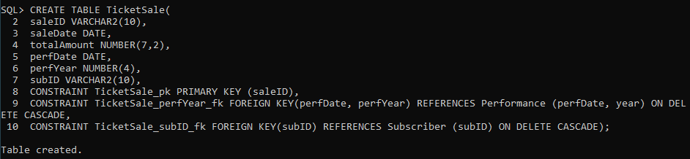

CREATE TABLE Ticket(

saleID VARCHAR2(10),

seatLocation VARCHAR2(10),

price Number(8,2),

type VARCHAR2(10),

CONSTRAINT Ticket_pk PRIMARY KEY (saleID, seatLocation));

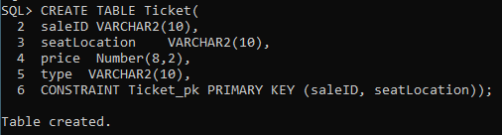

CREATE TABLE Sponsor(

sponsorID VARCHAR2(10),

name VARCHAR2(20),

street VARCHAR2(50),

city VARCHAR2(15),

state CHAR(2),

zip CHAR(5),

areaCode CHAR(3),

phoneNumber CHAR(7),

CONSTRAINT Sponsor_pk PRIMARY KEY (sponsorID));

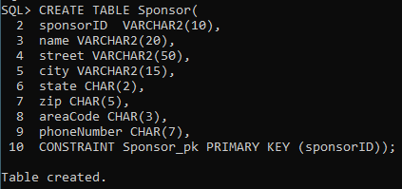

CREATE TABLE Donation(

sponsorID VARCHAR2(10),

donationDate DATE,

donationType VARCHAR2(20),

donationValue NUMBER(7,2),

year NUMBER(4),

seasonStartDate DATE,

CONSTRAINT Donation_pk PRIMARY KEY (sponsorID, donationDate),

CONSTRAINT Donation_year_season_start_fk FOREIGN KEY (year, seasonStartDate) REFERENCES PRODUCTION (year, seasonStartDate) ON DELETE CASCADE);

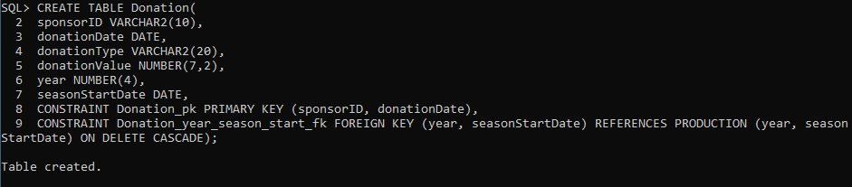

**Step 5.3 – Design SQL statements to create indexes for foreign keys and for any other columns that will be used most often for queries. Then execute the SQL statements in the database.** Show your work by providing screenshots of executing the SQL statements in the database.

create index memberid_duespymt

on DUESPAYMENT (memberId);

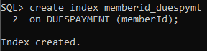

create index production_n1

on PRODUCTION (title);

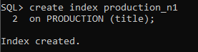

create index production_memberid

on MEMBERPRODUCTION (memberId);

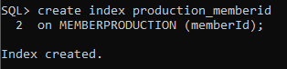

create index production_start

on MEMBERPRODUCTION (year, seasonStartDate);

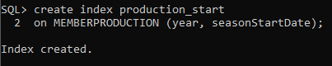

create index performance_start

on PERFORMANCE (year, seasonStartDate);

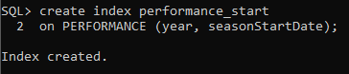

create index ticketsale_perfdate

on TICKETSALE (perfDate, perfYear);

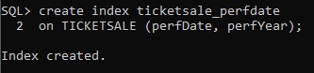

create index ticketsale_subid

on TICKETSALE (subID);

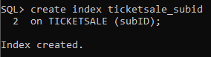

create index donation_start

on DONATION (year, seasonStartDate);

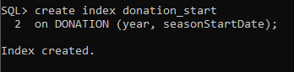

**Step 5.4 – Design SQL statements to insert at least five records in each table, preserving all constraints.** **Then insert the records into the tables.** Show your work by providing screenshots of executing the INSERT SQL statements in the database.

INSERT INTO Member VALUES(‘1111111111’, ’01-Jan-2000’, ‘Jonson’, ‘Jon’, ‘’, ‘’, ‘’ , ‘’, ‘’, ‘’, ‘’);

INSERT INTO Member VALUES(‘2222222222’, ’01-Feb-2002’, ‘Jonson’, ‘Ivan’, ‘’, ‘’, ‘’ , ‘’, ‘’, ‘’, ‘’);

INSERT INTO Member VALUES(‘3333333333’, ’01-Apr-2004', ‘Jonson’, ‘Bob’, ‘’, ‘’, ‘’ , ‘’, ‘’, ‘’, ‘’);

INSERT INTO Member VALUES(‘4444444444’, ’01-Jun-2010', ‘Jonson’, ‘Kat’, ‘’, ‘’, ‘’ , ‘’, ‘’, ‘’, ‘’);

INSERT INTO Member VALUES(‘5555555555’, ’01-Oct-2011’, ‘Jonson’, ‘Andry’, ‘’, ‘’, ‘’ , ‘’, ‘’, ‘’, ‘’);

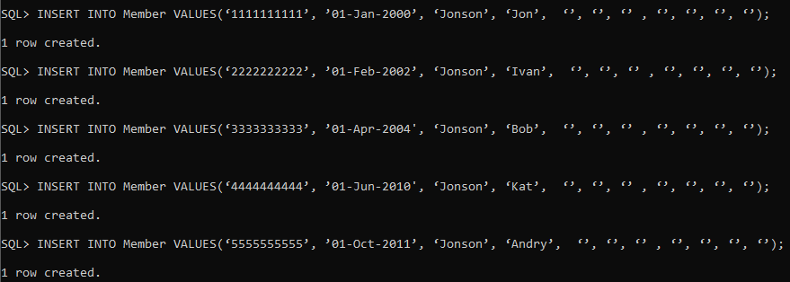

INSERT INTO DUESPAYMENT VALUES(2021, ‘1111111111’, 100, ’01-Jan-2021’);

INSERT INTO DUESPAYMENT VALUES(2021, ‘2222222222’, 100, ’01-Jan-2021’);

INSERT INTO DUESPAYMENT VALUES(2021, ‘3333333333’, 100, ’01-Jan-2021’);

INSERT INTO DUESPAYMENT VALUES(2021, ‘4444444444’, 100, ’01-Jan-2021’);

INSERT INTO DUESPAYMENT VALUES(2021, ‘5555555555’, 100, ’01-Jan-2021’);

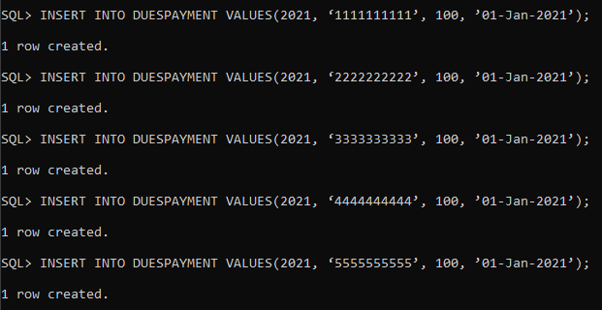

INSERT INTO Play VALUES(‘good story’, ‘Ivan Ivanov’, 01, 01);

INSERT INTO Play VALUES(‘very good story’, ‘Fedor Ivanov’, 02, 01);

INSERT INTO Play VALUES(‘sad story’, ‘Ivan Fedorov’, 01, 01);

INSERT INTO Play VALUES(‘just story’, ‘Victor Gold’, 02, 01);

INSERT INTO Play VALUES(‘Funny story’, ‘Jon Smith’, 01, 01);

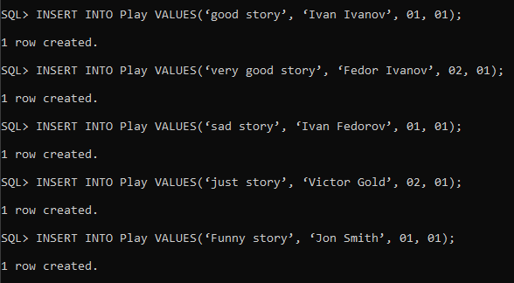

INSERT INTO Production VALUES(2010, ’01-Jan-2010’, ’01-May-2010’, ‘good story’);

INSERT INTO Production VALUES(2011, ’01-Jan-2011’, ’01-May-2011’, ‘very good story’);

INSERT INTO Production VALUES(2012, ’01-Jan-2012’, ’01-May-2012’, ‘sad story’);

INSERT INTO Production VALUES(2013, ’01-Jan-2013’, ’01-May-2013’, ‘just story’);

INSERT INTO Production VALUES(2014, ’01-Jan-2014’, ’01-May-2014’, ‘Funny story’);

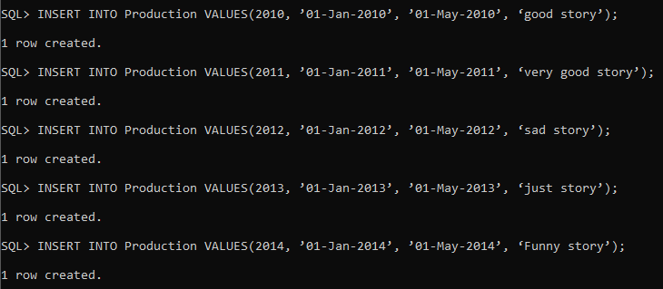

INSERT INTO MemberProduction VALUES(‘1111111111’, 2010, ’01-Jan-2010’, ‘dresser’, ‘pick up costume’);

INSERT INTO MemberProduction VALUES(‘2222222222’, 2011, ’01-Jan-2011’, ‘dresser’, ‘pick up costume’);

INSERT INTO MemberProduction VALUES(‘3333333333’, 2012, ’01-Jan-2012’, ‘dresser’, ‘pick up costume’);

INSERT INTO MemberProduction VALUES(‘4444444444’, 2013, ’01-Jan-2013’, ‘dresser’, ‘pick up costume’);

INSERT INTO MemberProduction VALUES(‘5555555555’, 2014, ’01-Jan-2014’, ‘dresser’, ‘pick up costume’);

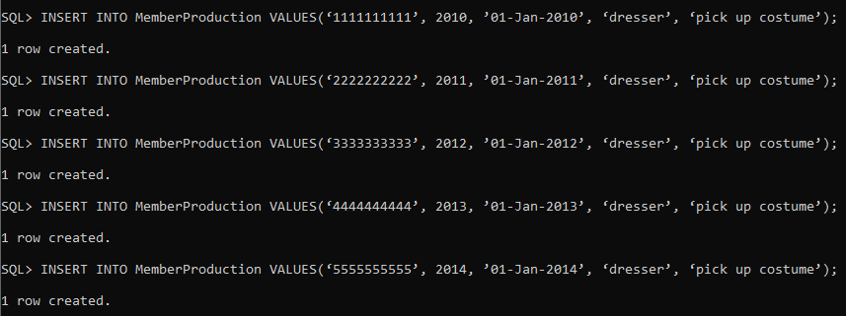

INSERT INTO Performance VALUES(’01-Feb-2010’, 2010, ‘06:00’, ’01-Jan-2010’);

INSERT INTO Performance VALUES(’07-Feb-2010’, 2010, ‘06:00’, ’01-Jan-2010’);

INSERT INTO Performance VALUES(’14-Feb-2010’, 2010, ‘06:00’, ’01-Jan-2010’);

INSERT INTO Performance VALUES(’21-Feb-2010’, 2010, ‘06:00’, ’01-Jan-2010’);

INSERT INTO Performance VALUES(’28-Feb-2010’, 2010, ‘06:00’, ’01-Jan-2010’);

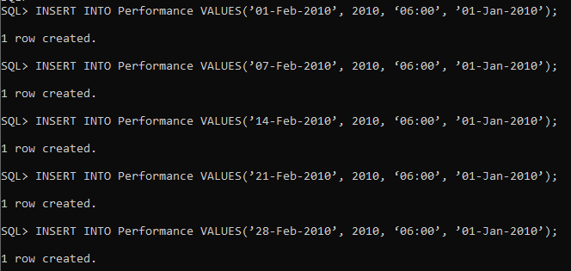

INSERT INTO Subscriber VALUES(‘1922929814’, ‘Fernando’, 'Juarez’, ‘69 Park Place’, ‘New York City’, ‘NY’, ‘19322’, ‘516’, ‘2143201’);

INSERT INTO Subscriber VALUES(‘0395322294’, ‘Yonny’, ‘Yonson’, ‘19 Manor Rd.’, ‘New York City’, ‘NY’, ‘10291’, ‘718’, ‘2451920’);

INSERT INTO Subscriber VALUES(‘5992819190’, ‘Cole’, ‘Trayn’, ‘42 Porque Place’, ‘New York City’, ‘NY’, ‘13932’, ‘315’, ‘4919104’);

INSERT INTO Subscriber VALUES(‘6195921325’, ‘Sam’, ‘Ayeam’, ‘939 Bazaar Rd’, ‘New York City’, ‘NY’, ‘19282’, ‘347’, ‘2934935’);

INSERT INTO Subscriber VALUES(‘1843823471’, ‘Isgona’, ‘Dai’, ‘119 Strait Ave.’, ‘New York City’, ‘NY’, ‘10541’, ‘347’, ‘5399349’);

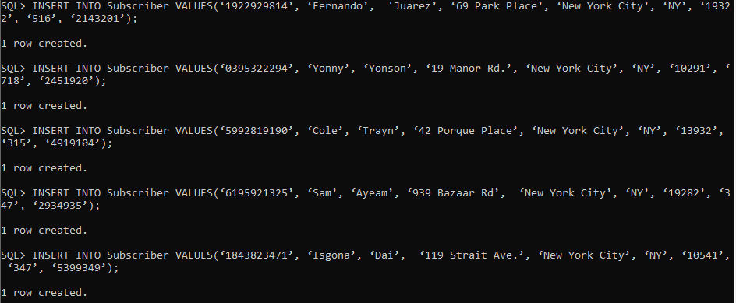

INSERT INTO TicketSale VALUES(‘0000000001’, ’01-Feb-2010’, 20.00 ,’07-Feb-2010’, 2010, ‘0395322294’);

INSERT INTO TicketSale VALUES(‘0000000002’, ’01-Feb-2010’, 16.00,’07-Feb-2010’, 2010, ‘1922929814’);

INSERT INTO TicketSale VALUES(‘0000000003’, ’01-Feb-2010’, 14.00,’07-Feb-2010’, 2010, ‘5992819190’);

INSERT INTO TicketSale VALUES(‘0000000004’, ’01-Feb-2010’, 16.00,’07-Feb-2010’, 2010, ‘6195921325’);

INSERT INTO TicketSale VALUES( ‘0000000005’, ’01-Feb-2010’, 20.00,’07-Feb-2010’, 2010, ‘1843823471’);

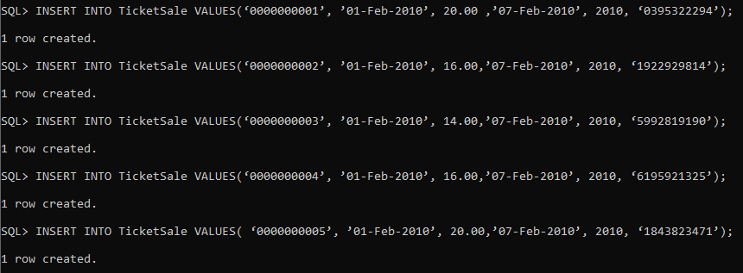

INSERT INTO Ticket VALUES(‘0000000001’, ‘R-1 S-12’, 20.00, ‘’ );

INSERT INTO Ticket VALUES(‘0000000002’, ‘R-5 S-4’, 16.00, ‘’);

INSERT INTO Ticket VALUES(‘0000000003’, 'R-10 S-1’, 14.00, ‘’);

INSERT INTO Ticket VALUES(‘0000000004’, 'R-6 S-7', 16.00, ‘’);

INSERT INTO Ticket VALUES(‘0000000005’, 'R-3 S-5', 20.00, ‘’);

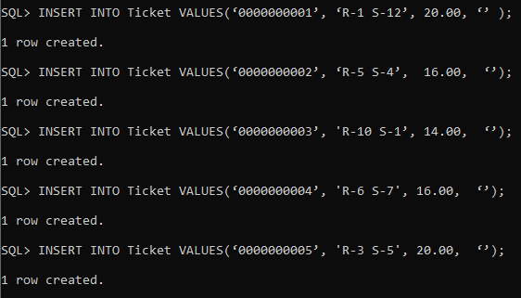

INSERT INTO Sponsor VALUES(‘9248192533’, ‘Mac Afi’, ‘123 Lowe St.’, ‘New York City’, ‘NY’, ‘13934’, ‘212’, ‘3429575’);

INSERT INTO Sponsor VALUES(‘3955945319’, ‘Sheena Karra’, ‘83 LoveLace Ave.’, ‘New York City’, ‘NY’, ‘24933’, ‘718’, ‘2921943’);

INSERT INTO Sponsor VALUES(‘1994793320’, ‘Tom Bamadil’, ‘523 Gineve Place’, ‘New York City’, ‘NY’, ‘12839’, ‘347’, ‘1092042’);

INSERT INTO Sponsor VALUES(‘1837438312’, ‘Barry Kimble’, ‘184 36th St.’, ‘New York City’, ‘NY’, ‘10412’, ‘212’, ‘9312920’);

INSERT INTO Sponsor VALUES(‘5211902212’, ‘Zoe Springfield’, ‘46 10th St.’, ‘New York City’, ‘NY’, ‘19931’, ‘212’, ‘3241492’);

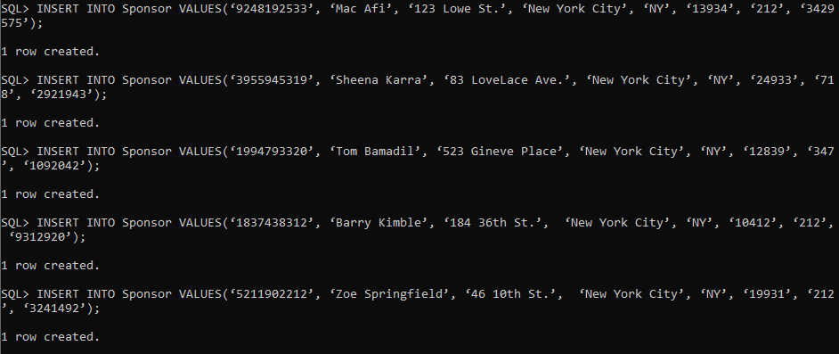

INSERT INTO Donation VALUES(‘9248192533’, ‘22-Jul-2009’, ‘Cash’, 500.00, 2010, ’01-Jan-2010’);

INSERT INTO Donation VALUES(‘3955945319’, ‘1-Dec-2009’, ‘Cash’, 850.00, 2010, ’01-Jan-2010’);

INSERT INTO Donation VALUES(‘1837438312’, ‘1-Jul-2009’, ‘Cash’, 1000.00, 2010, ’01-Jan-2010’);

INSERT INTO Donation VALUES(‘1994793320’, ‘13-Jun-2009’, ‘Cash’, 600.00, 2010, ’01-Jan-2010’);

INSERT INTO Donation VALUES(‘5211902212’, ‘1-Feb-2009’, ‘Cash’, 650.00, 2010, ’01-Jan-2010’);

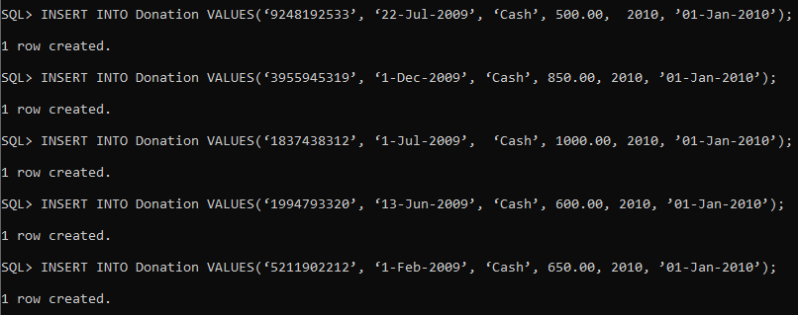

**Step 5.5 – Design SQL statements that will process five non-routine requests for information from the database. Then execute the SQL statements in the database.** Show your work by providing screenshots of executing the SQL statements in the database along with the results.

**Find Sponsors with the area code 212.**

SELECT *

FROM Sponsor

WHERE Sponsor.areaCode = ‘212’;

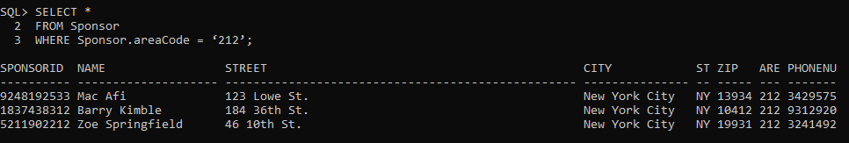

**Find the saleIDs and seatLocations of tickets that cost less than 20.00.**

SELECT saleId, seatLocation

FROM Ticket

WHERE price < 20.00;

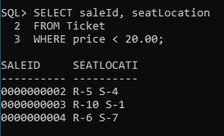

**Find the names of sponsors who donated more than 600.00.**

select S.name, sum(D.donationValue)

FROM Donation D, Sponsor S

where S.sponsorId = D.sponsorId

group by S.name

having sum(donationValue)>600;

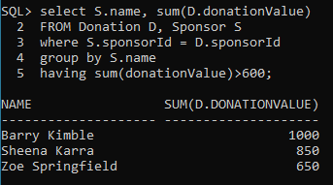

**Find the productions that were shown before 2014.**

SELECT *

FROM Production

WHERE Production.year < 2014;

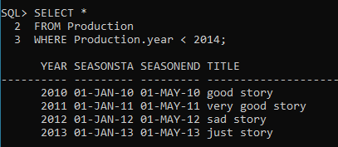

**Find the play associated with the author Ivan Ivanov.**

SELECT *

FROM Play

WHERE Play.author = ‘Ivan Ivanov’;

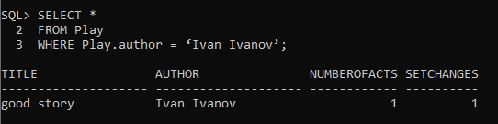

**Step 5.6 – Design one trigger for your project. Then create the trigger in the database.** Show your work by providing screenshots of creating the trigger in the database.

CREATE or REPLACE TRIGGER member_t1

BEFORE INSERT OR UPDATE on member

REFERENCING NEW AS NEW OLD AS OLD

for EACH ROW

BEGIN :NEW.WHO_UPDATED := USER;

:NEW.WHEN_UPDATED := SYSDATE;

END;

/

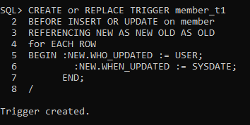

**Step 5.7 – Design and execute SQL statements to demonstrate that the trigger is working as expected.** To demonstrate that the trigger is working as expected, provide a screenshot of the data before and after the trigger is executed.

insert into member (memberId, dateJoined, lastName, firstName, street, city, state, zip, areaCode, phoneNumber, currentOfficeHeld)

VALUES (‘6666666666’, ’01-Jun-2022', ‘Luthor’, ‘Lex’, ‘Wayne Ave’, ‘West Nyack’, ‘NY’ , ‘10956’, ‘914’, ‘7398290’, ‘President’);